SleepWear

Project Plan

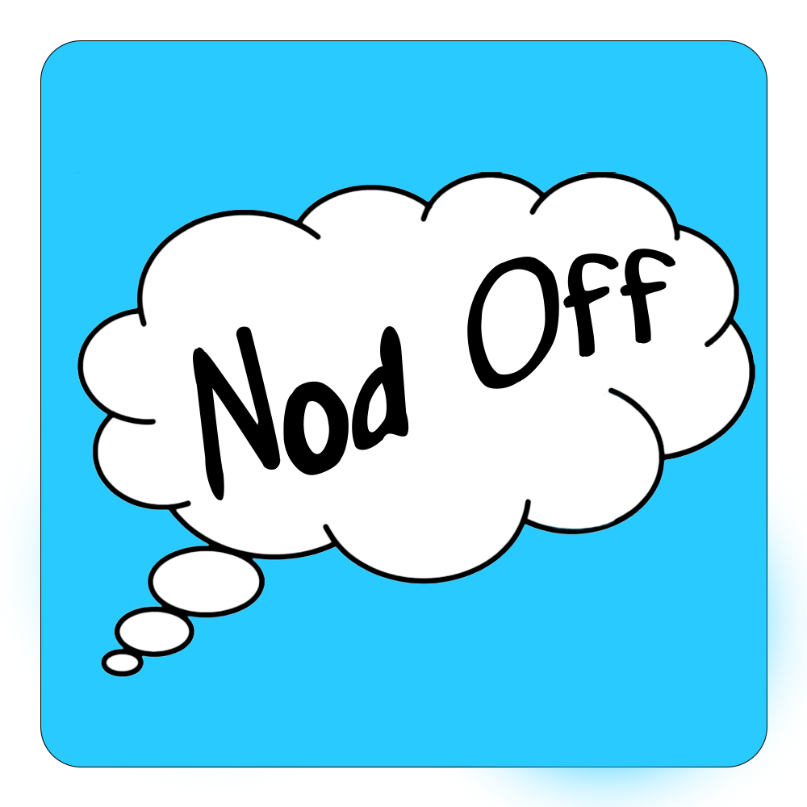

2/22/2023

Cristan Vargas, Dylan Odell, Jonathan Enriquez, Joshua Babu

1. Introduction
   1. **Scope and purpose of the document** - The purpose of this document is to provide goals and objectives of the project, as well as milestones. What’s contained in this document is our system scope, anticipated business and personal benefits, problem and opportunity description, system capabilities and features of the application. Nod Off is an application designed to allow you to track your sleep and sleeping habits. It also contains the project schedule, system context diagram, team organization and tracking control mechanisms. It does this by utilizing various features like, using biometric data to determine sleep patterns, and an alarm for waking up. In addition, Sleep Journal allows users to jot down their dreams, which integrates with sleep tracking.
   2. **System scope**

i. Problem/opportunity Description - Nod Off is hoping to stop HEAVY sleepers from sleeping through their alarm. We know that shaking beds, and loud noises isn't the most ideal solution for everyone. For instance no other person in the household is going to want to hear an extremely loud noise that stays on for 10 minutes and the person is still snoring away. Smarthomes are becoming more common in every household today than ever before. By utilizing technology already acquired by the user we branch new uses for that smart home device and we are assisting in awakening a user with smart bulbs or smart blinds.

ii. Anticipated business/personal benefits -

1. **What is Nod Off looking for?**

* We are looking for users to worry less about waking

up late or worrying about encountering an unpleasant sleep. We want users to track their own sleep in their own personalized logs. Almost as a user's personal app. We want to eventually utilize graphs to show a user what their data has achieved in one week, one month, one year, or five. We want this app to benefit the user in any way. A good sleep is a good day and a good day is a good sleep.

1. **What do we want for the user?**

* Nod Off would hope to achieve an interest in sleep statistics to our users while also looking to provide solutions to a user that experiences unpleasant sleep. The ability to detect REM cycles with movement can be crucial to waking someone up in the right cycle and does not disrupt sleep. A Lot of people experience bad sleep, it may be the pillow, the temperature but nothing is worse than continuing the day groggy. We believe that being awakened in the wrong cycle during REM can affect your brain. Nod off will use data tracking(once granted permission by user) to log their sleep motions(through the apple watch), log their dreams as they wake up and analyze gained data by the user to formulate a proper time to awaken the user(light or heavy).

iii. System capabilities - **Track sleep**

* + - 1. Use biometric data to determine sleeping patterns and quality of sleep
         1. Wearables integrates with(Apple watch, fitbit, Samsung watch)

Heart rate

Oxygen Saturation

Movement (accelerometer)

* + - * 1. Phone

Movement (accelerometer)

Activity (phone wake event)

**2. Sleep Journal** - Log Sleep Data on Calendar

* Keep track of dreams by allowing user to record their dreams in a journal, can also integrate with sleep tracking

**3. Alarm** - Smart Home Integration to alarm clock

- Integrate with Amazon Alexa and Google Home to

create custom alarms

* Automatically wake you up around a user's defined time to help you get a better night's sleep.

iv. System context - (**In** **GitHub**)

1. **Schedule - (In GitHub)**
2. Staff Organization
   1. **Team Structure**

* Leader: Cristian Vargas
* Project Scheduling: Joshua Babu and Dylan Odell
* System Context Diagram - Jonathan Enriquez and Cristian Vargas
* GitHub: Jonathan Enriquez and Joshua Babu
* Trello: Cristian Vargas and Dylan Odell

1. **Tracking and control mechanisms** - In order to track the changes on all Documents. We actively have a Google Drive for us to easily access all files in relation to our app development. The Project Schedule will be in our Github repository so that when assignments are completed or any due date has been pushed back, either Joshua or Johnathan are able to make changes. In order to mark down completed tasks or ones that are pending Cristian and Dylan will use Trello to organize our workflow and make sure one task gets completed before the next. In order for us to set up work time, we use our SMS group chat to conclude a meeting time. While working on the assigned task(s) we use Discord to share ideas, learn something or decide which members will be doing which tasks for that day.